

SOEN 6441 (Advance Programming Practices)

Project: Risk: Strategy Build 1

GitHub repository - https://github.com/credo92/RiskConquer

Team 19:

Member Name | Student Id
Rahul Goyal
Garvpreet Singh
Gurpreet Singh
Vipul Srivastav

Submitted to: Dr. Joey Paquet
Contents
1.1 Scope: 2
1.2 Architecture Style 3
1.3 Risk Strategy. Modules Description 3
1.3.1 1.1 Controllers 3
1.3.2 1.2 Entity 4
1.3.3 1.3 Utility 4
1.3.4 1.4 Model 5
1.3.5 1.4 Validate 5
1.3.6 1.4 Main 5
1.3.7 1.4 Exception 5
1.4 Technologies and Tools used: 6
1.4.1 Tools and technology used for the development of the game. 6

Introduction
This introduction provides an overview of the entire Software Architecture Document for the Risk Strategy game. It includes the purpose, scope, overview of the system.

Scope:

The scope of the build 1 is as per the instruction guidelines for the build:

MapEditor: Covering the following below functionality, which is a form of a connected graph with proper interconnection between the continent and territories and abiding to the conquest map file format.
- Create a new map file
- Edit an existing map file
- Add/update/delete Continent
- Add/update/delete Territory
- Add/Delete Adjacent Territory
- Make sure that the integrity of the connected graph is maintained.
- Game Playe : The game play covers:
  - Assigning territory to player
  - Player ability to assigning armies to each territory in round robin manner
  - Reinforcement phase, with proper calculation of armies
  - Fortification phase, with a valid fortification move.

Architecture Style
Following the MVC design pattern for implementing user interfaces on computers. It divides a given application into three interconnected parts. This is done to separate internal representations of information from the ways information is presented to, and accepted from, the user. The MVC design pattern decouples these major components allowing for efficient code reuse and parallel development.

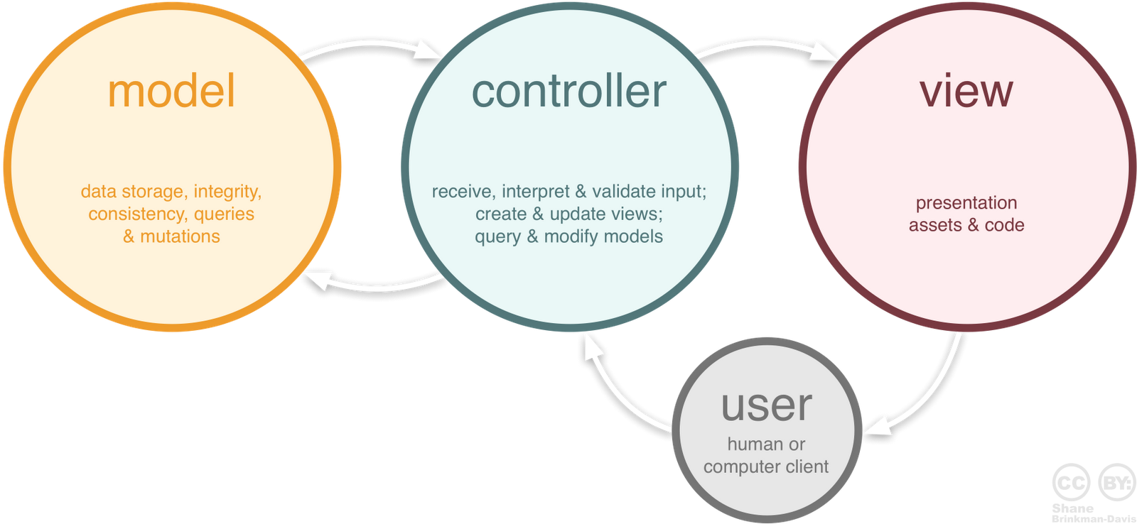

Risk Strategy. Modules Description

1.1 Controllers
The Controllers folder includes the Game and Map controller modules of the risk game.
File_Name | Description
GamePlayController | The class acts as a mediator between the GameModel class and the GameView file. It captures all the user action like :  - Creation of player  - Assigning armies  - All the three phases of the risk game (Reinforcement, Attack, Fortify)  and updates the GameView based on the data changed published by the GameModel class.  It also serves to all the request issued by the GameView.
MapEditorController | This class act as a mediator between the GameModel and the MapEditorView. It captures all the user actions like:  - Add/Update/delete Continent/Territory/Adjacent Territories  It update the MapView based on the data changed published by the MapModel.  It also serves to all the request issue by the MapView

1.2 Entity
The Entity folder includes all the entities used in the game.
File_Name | Description
Map | It contains all the information of the Map file like: author, name  It contains a list of the continents that forms a map
Continent | It contains all the information related to the continent like , name , control value  It contain a list of all the territories that belong to a continent.
Territory | It contains all the information related to the territory like , name, x/y coordinates  It also maintains a refrence to which continent the territory belongs  It also maintains a list of all the adjacent territory of this territory.  It contains the count of armies currently residing on the territory  It conatin a refrence to the player, indicating which player holds the territory.
Player | It contains all the information related to a player, like player name, list of territory assigned to the player.  It contains the number of armies associated with the player.

1.3 Utility
The Utility folder includes all the elements used in the map file.
File_Name | Description
MapFileParser | This class is responsible for reading the Conquest map file format and parsing in to Map object. It also checks for the validity of the data of the map file.
MapFileWriter | This class is responsible for writing the Map object to the file in the same format as read from the conquest file
MapUtil | Contains all the utility method like: pushing data to console, saving map object, opening a dialogue box.

1.4 Model
The Model folder includes all the phases in the risk game
File_Name | Description
GameModel | This class represents the Game Model like creating players, assigning territory to the player, calculating the reinforcement armies, get the continents are owend by the players.
MapModel | This class represents the Map model and perform operation like , add/update/delete territory, add/update/delete continent.

1.4 Validate
The Validate folder includes all the phases in the risk game
File_Name | Description
MapValidator | This class represents the validation functionality of the map. It validate all the possible combination of Continents and territory and making sure that the remain as a connected graph.

1.4 Main
The Main folder includes all the phases in the risk game
File_Name | Description
CreateMap | Helps to load the new map screen
GamePlay | Helps to load the Game play screen
Main | Main entry point for the application
MapEditor | Help to load the map editor screen
MapOption | Helps to load the map options screen

1.4 Exception
The Exception folder includes all the phases in the risk game
File_Name | Description
InvalidMapException | Custom exception class to manage exception of the game.

Technologies and Tools used:

Tools and technology used for the development of the game.
Technology and Tools | Description
Eclipse | IDE for the game development
Maven | Maven as a build automation tool to manage all project dependencies.
JavaFx | Library to control the UI components of the Risk Game
FXML Editor | To generate the UI components for the Risk Game
Junit 4 | Junit 4 for writing test cases

